**PG SEARCHING SYSTEM**

**Data Flow Diagram**

**Context level**

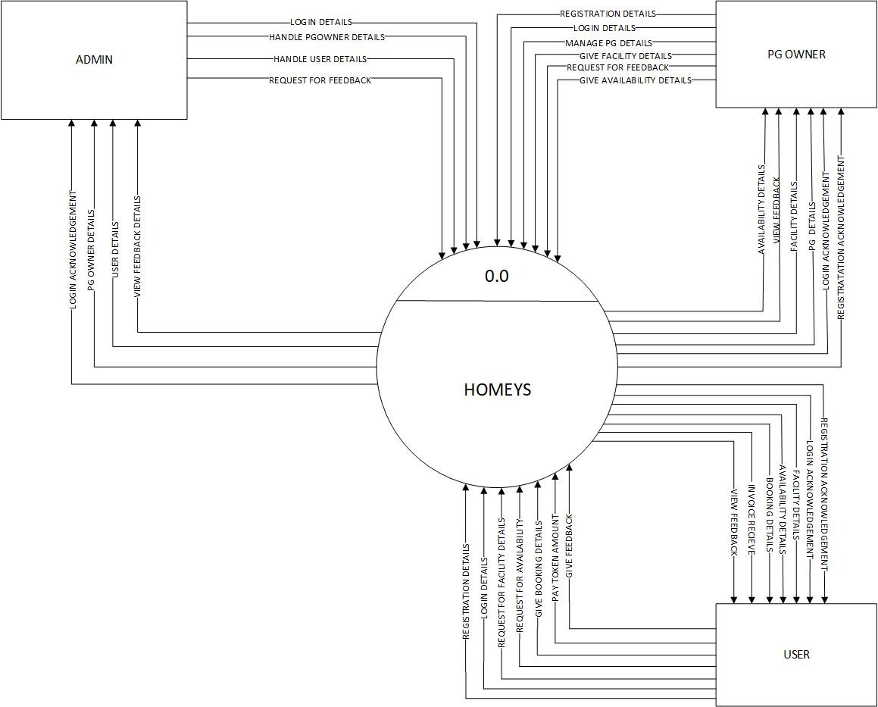

PG Searching System

LEVEL 1 DFD

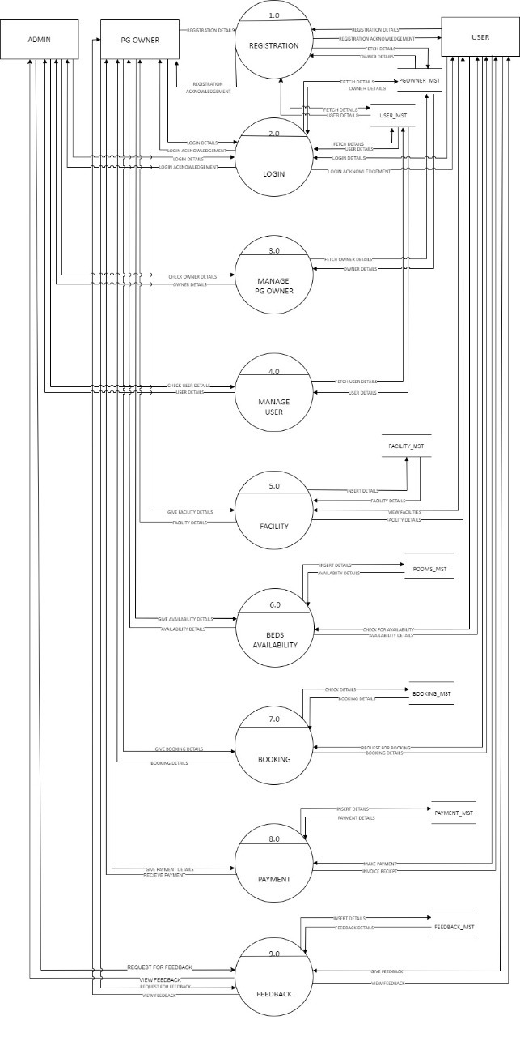

LEVEL 2 DFD

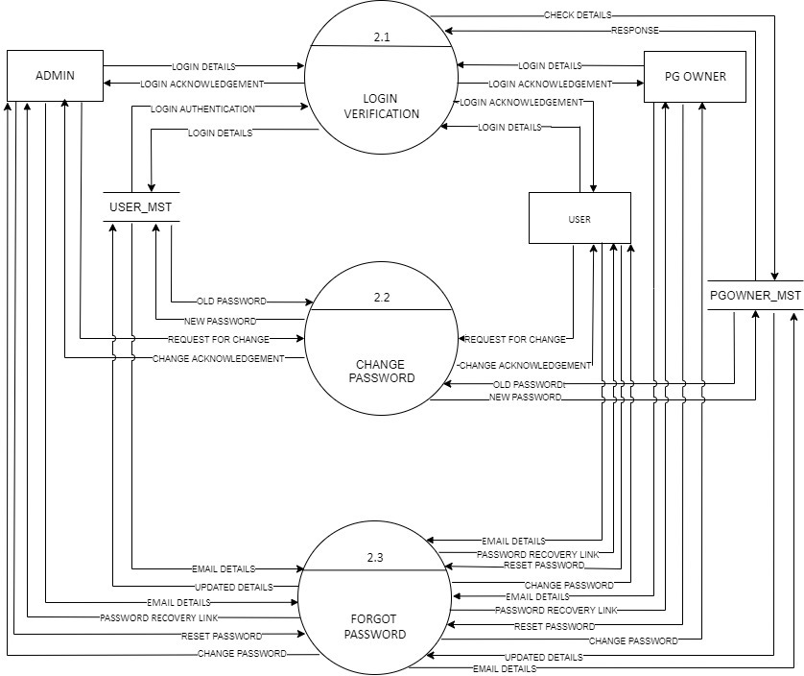

LEVEL 3 DFD

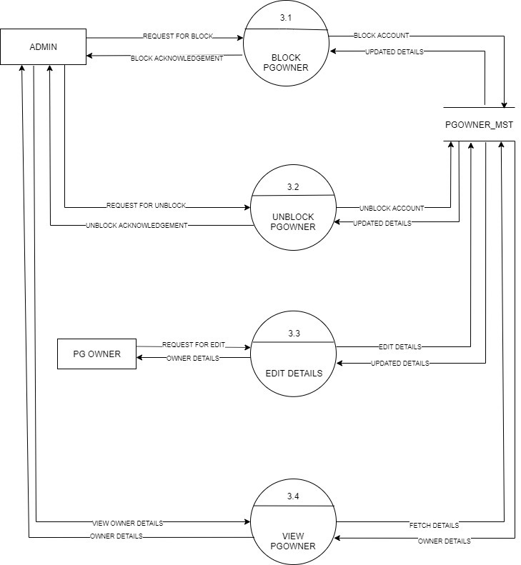

LEVEL 4 DFD

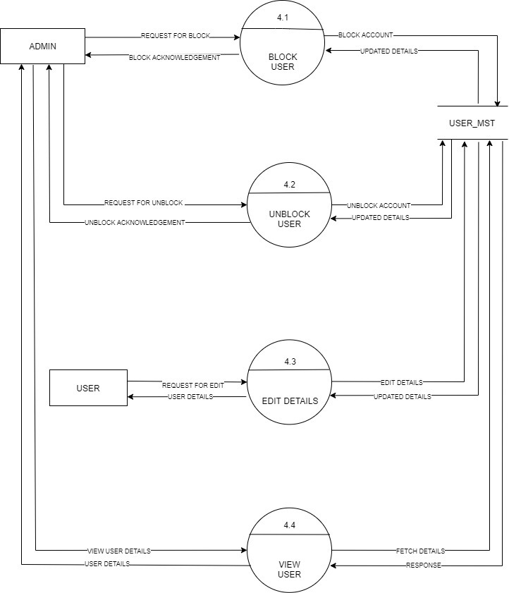

LEVEL 5 DFD

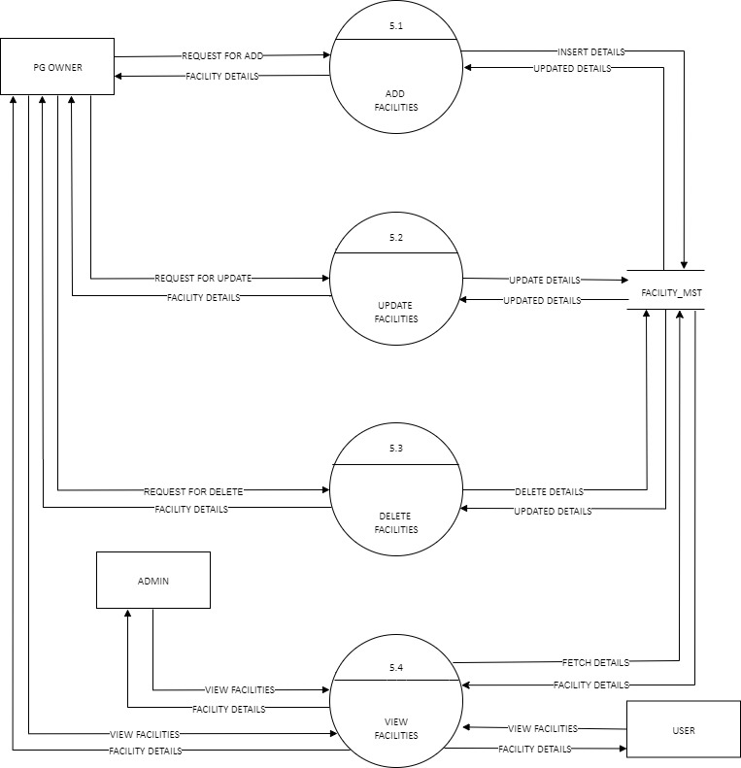

LEVEL 6 DFD

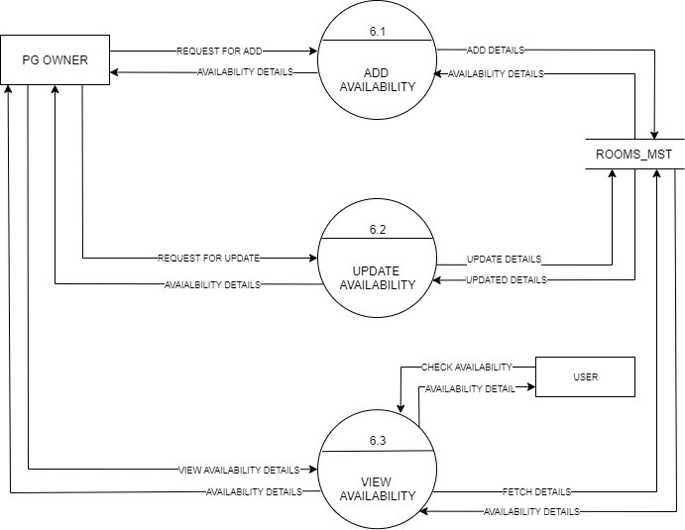

LEVEL 7 DFD

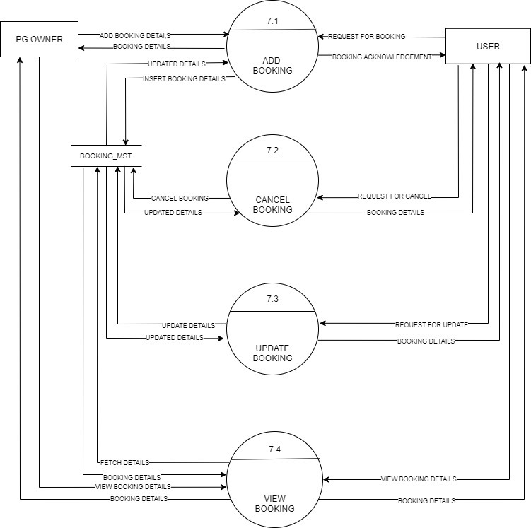

LEVEL 9 DFD

